# **About Myself**

|  |  |  |  |
| --- | --- | --- | --- |
| Name: | Shubham Jain | Father’s Name: | Mr. Pawan Jain |
| Address: | A-13, CEL Apartments, Vasundhara Enclave, Delhi-110096 | Email: | sjain251298@gmail.com |
| Contact: | +91 8558859060 | DOB: | 25th December ,1998 |

# Personal Profile

I am young hardworking motivated learner eager to expand my boundaries in the today’s field of Computers and Information Technology. Currently I am doing B-Tech from Thapar Institute of Engineering and Technology in Computer Science and I am eager to serve your esteemed organization as an Intern.

# Education

2014-2015: Matriculated from Apeejay School, Noida under CBSE Board securing 10.0 CGPA.

2016-2017: Completed 12th from Ahlcon Public School, Delhi under CBSE Board securing 95% in main subjects.

2017-2018:

* Year of Joining Thapar University.
* Did many projects as well as personality improvising co-curricular activities and recently, I completed my 3rd Year with a GPA of 8.00.

# Skills and Field of Interest

MYSQL & PLSQL

C/C++

ARDUINO

Html + CSS

PHP (Server Scripting)

# Hobbies and leisure activities

* I am an enthusiastic programmer and have keen interest in learning new skills.
* Badminton is my all-time sport and I am good enough at it.
* I enjoy reading fiction books, solving puzzles and socializing with friends and family.

# Projects and Past Experience

* Internship cum Training at KEI Industries Ltd.:

This Being my first training session at KEI Industries Ltd. started on 20th May 2018 with a time span of 6 weeks.

From this training I enhanced my skills in the field of Web Development along with Database Management and started working to become an efficient Web Developer and so far, I have worked upon the following projects:

* Internship at Placeholder Digital Solutions pvt Ltd.:

Got selected as an intern in the month of march ,2019 and currently working as a Web Developer in Placeholder Digital Solutions Ltd. (Work from home).

* 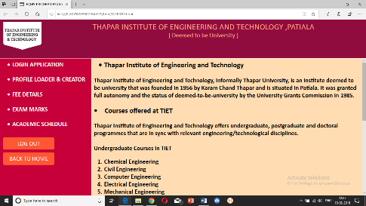Web-Kiosk Project:

I made this project while I was serving KEI industries Ltd. It is basically a demo model of a student management portal for a college/school made only using html and C++.

* 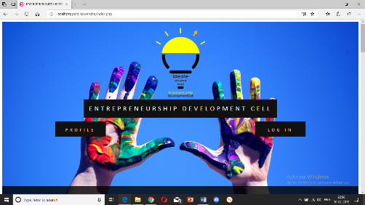Entrepreneurship Development Cell Project:

I served the Entrepreneurship Development Cell of my college and made a sample website for its representation. In this I used HTML + CSS for Frontend, PHP for backend and MYSQL for queries, Adobe Photoshop for Image Editing.

* 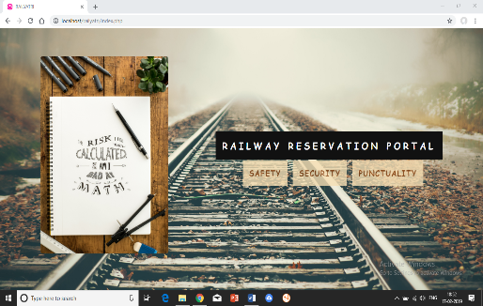Railway Reservation Portal:

I made a Mini Railway Reservation Portal as a project to be submitted as a remark of what I learned from the course named DBMS being taught to us. This also used the same languages HTML +CSS, PHP, MYSQL and WampServer for a Virtual Server.

* 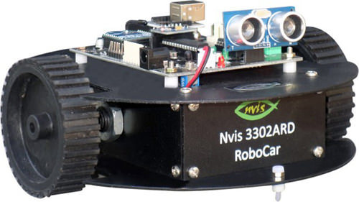Buggy Project:

This project requires Arduino Programming as well as sufficient information about the various microcontrollers, sensors & how they work. This smart buggy is programmed to follow black line & park itself automatically while being operated wirelessly.

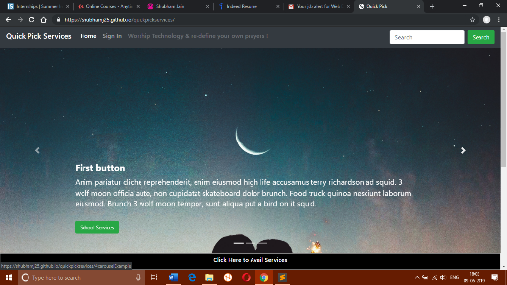Quickpick Express:

This project is based on the motive of providing various online services to the college freshers so that goods get available to them at cheaper rates. Thus, I attach a sample repository to this:

View: <https://shubhamj25.github.io/quickpickservices/>

Source: <https://github.com/shubhamj25/quickpickservices>

# References

* Mr. Ashish Jain

Project Leader

INFOSYS Ltd.

Contact: +91 8884072111